Name:
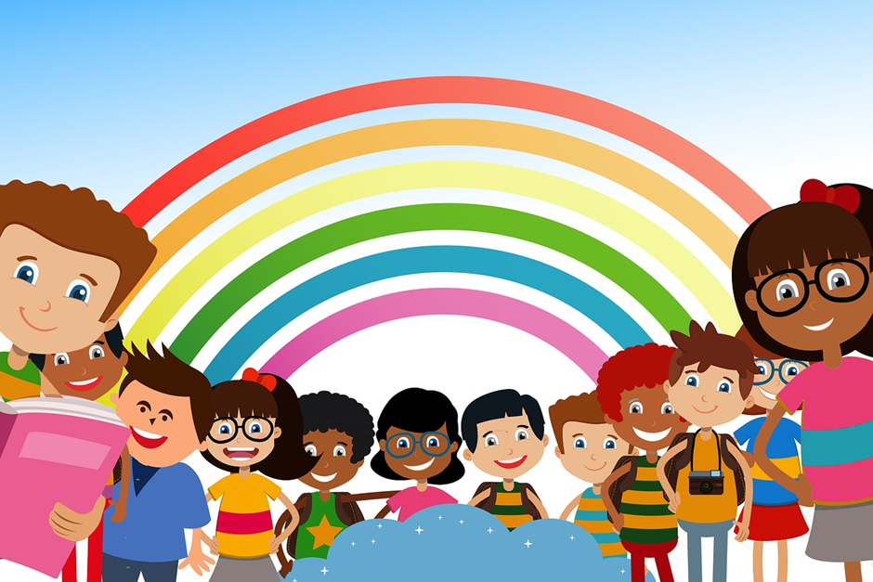

“ We are the rainbow children”

Design a magical creature
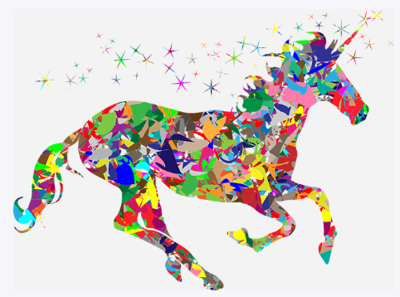
How will it move? What are their magic powers? Is it similar to any other animals? What’s it called?

Rainbow Spectrum
How many words can you make from the two words above? Why not write each word in a different colour?

Rainbow Rocket
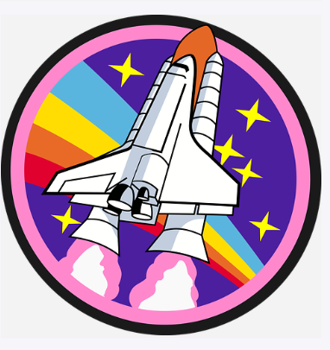
If you were in a rocket ship and could fly anywhere in the galaxy, where would you go? Why? What would you do? What would you see?

Rainbow Wordsearch
G | R | E | E | N | E | V | C | A | E
F | Y | L | G | Y | G | B | L | Y | K
E | A | Z | E | U | L | B | V | T | Y
G | I | N | D | I | G | O | L | E | J
N | B | Q | R | G | C | X | L | L | B
A | R | O | E | D | L | L | I | O | J
R | L | D | D | W | O | R | S | I | N
O | S | F | K | W | L | W | G | V | X
Green
Red
Yellow
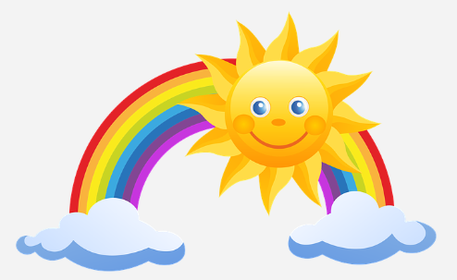
Blue
Orange
Indigo
Violet
Rainbow Designer
Use your colour skills to make this umbrella a true show stopper.
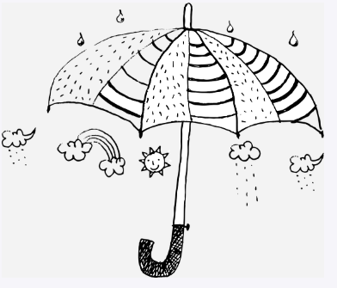
Polaroid Picture
What have you done during the past few weeks? Draw your 3 favourite moments and then write about them.
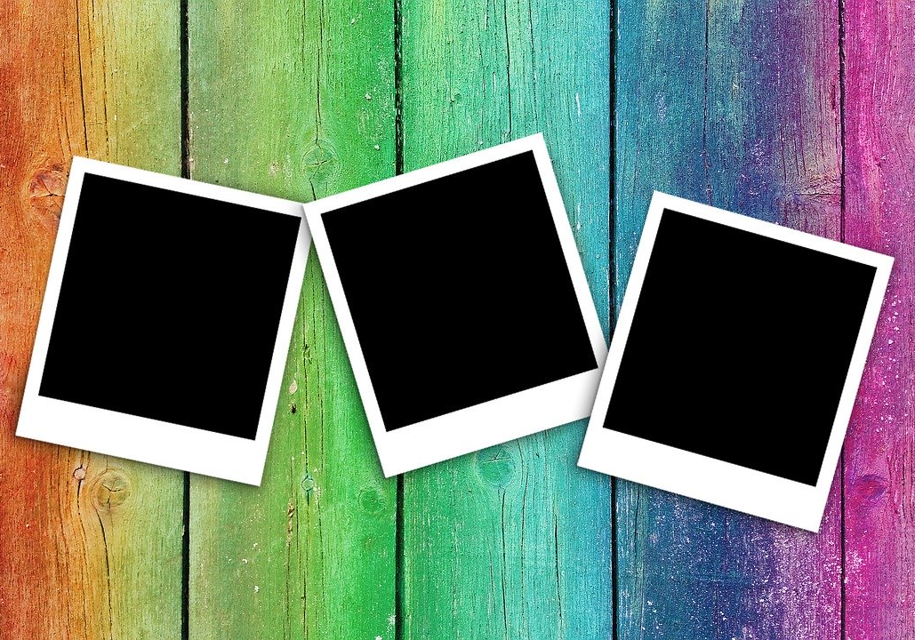

Pot of Gold
What do you think is found at the bottom of the rainbow? What would you wish for? Draw a picture of the treasure you would hope to find.

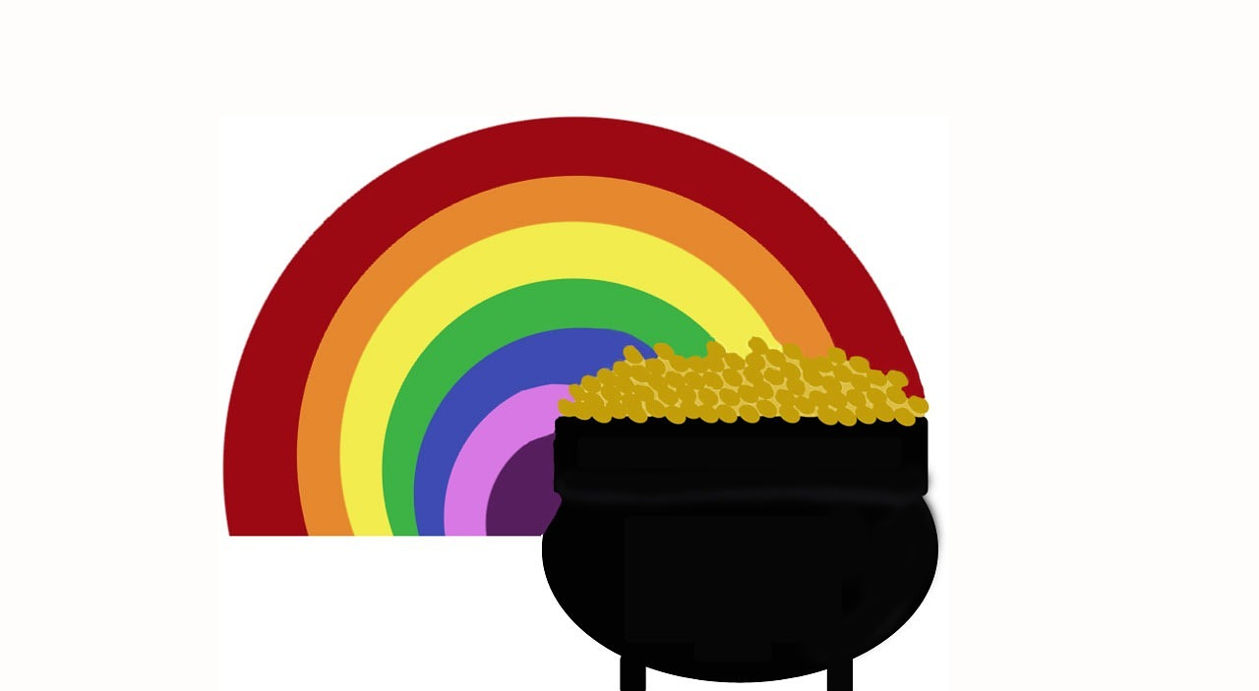
Rainbow Design
Design your own rainbow picture.
